S2 2020 FIT5057 Assignment 3 - REFLECTIVE REPORT

Table of Content
1. Introduction
2. Reflective Thinking Model
3. Reflective Thinking Outcomes
3.1 Task 1
3.1.1 Introduction/Objective
3.1.2 Reflection Discussions
3.1.3 Conclusion/Reflections Evaluation
3.1.4 Improvement Action List
3.2 Task 2
3.2.1 Introduction/Objective
3.2.2 Review and Reflection of Framework
3.2.3 Proposed Policy
3.2.4 Conclusion/Reflections Evaluation
4. Conclusion
5. References

1. Introduction
This is FIT5057 Assignment 3 – Reflective Report. There are three main learning objectives for this assignment.
Firstly, this assignment will help us to understand and assess the responsibility of contemporary project managers in IT projects by applying reflective thinking. According to Kurt (2017), reflective thinking is a very useful self-directing strategy that can help us think about our deficiencies in practical problems and keep improving ourselves. It will broaden and consolidate our PM knowledge and benefit our ongoing projects or future projects.
Secondly, this assignment will show us how to comprehend and judge plenty of project management methodologies including those we have learnt in the PMBOK(2017). We will rethink the project management methods learned in PMBOK and evaluate them. Reflecting on the effect of combining theories with practical applications and getting more thoughts from it will further deepen our understanding of all aspects of project management.
Finally, how to obtain high-quality reflection depends on the degree of our original comprehension of theoretical knowledge when learning project management. This assignment will lead us to apply the reflective thinking in our previous Assignment 1 and Assignment 2 and use this experience to deepen our knowledge of project management methodologies.
Overall, this assignment, together with the previous two assignments, will teach us the concept of reflective thinking and how to utilize it in improving our ability of project management.
To start with, we will look at the 2 given meta-questions and the sub-questions followed.
Meta question 1: What have you learned from the two previous assignments?
Sub-question: 1) What did you do? 2) What is your reflection on your works?
Meta question 2: In assignment 2, what is the shortage in the framework and how should we implement cybersecurity features in it?
Sub-question: 1) What cybersecurity policy do the reference articles use? 2) What are the security vulnerabilities in your framework? 3) How to develop a cybersecurity policy for your work? 4) What does this learning experience bring to you? 5) What can you improve from this experience?
2. Reflective Thinking Model
Reflective thinking contains various aspects of problems that we need to consider. To reflect on the previous experience in a more structured order, we introduce the reflective thinking model to assist us to make our mind clear.
I choose Gibbs’ reflective cycle as my reflective thinking model. As Potter (2015) stated, the benefit of Gibbs’ cycle is that this model will cover different aspects of the project in details. There are six steps in the Gibbs Model: description, feelings, evaluation, analysis, conclusion, and action plan. Together they form a solid framework that helps us to assess what, who, when, where, why, and how in our previous learning process.
I have made a diagram to specifically show how I will apply Gibbs’ cycle to my previous assignment 1 and 2. (See next page Fig 1.)
The Description is about summarizing what I have done in Individual Assignment 1 and Group Assignment 2. The Feelings shows how I feel about these 2 assignments – both during the process and after receiving the grades. I apply reflective thinking on Evaluation part by looking back to see what I did well and what I did terribly. In Analysis part, I analyzed what the motivation was to push me doing these assignments. I made several conclusions about what I learnt from these assignments in the Conclusion part. Finally, the Action Plan part enables me to prepare better next time by making an improvement solution.
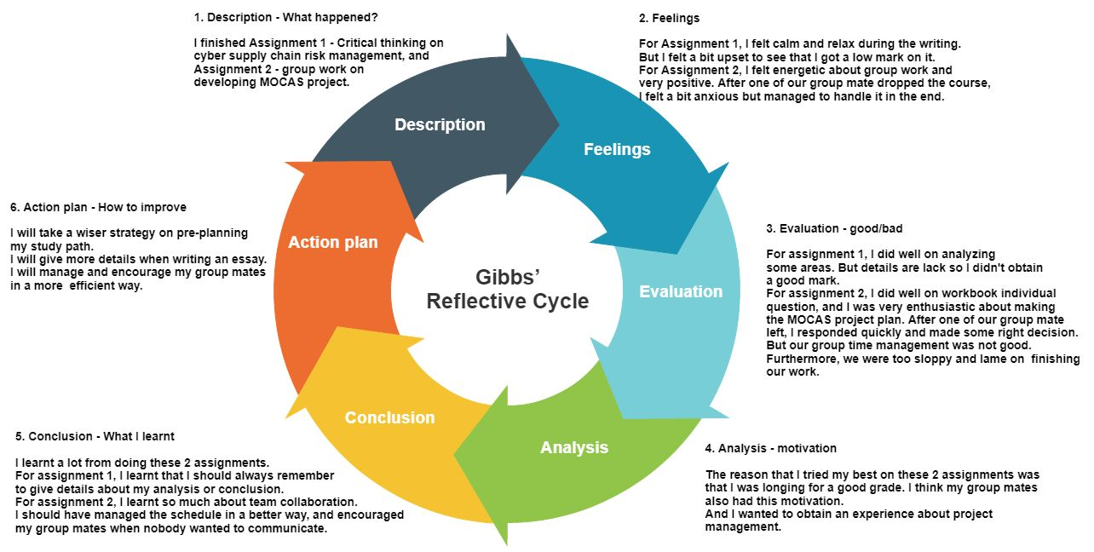
Fig 1. Gibbs’ Reflective Cycle
3. Reflective Thinking Outcomes
3.1 Task 1
3.1.1 Introduction/Objective
The objectives of task 1 are Assignment 1 and Assignment 2 since the meta-question ask us to reflect on these assignments.
3.1.2 Reflection Discussions
- What did I do?
1. Comparing A1 & A2
For Individual Assignment 1, I read and learnt critical thinking and applied it on analyzing cyber supply chain risk management by independently writing my own essay.
For Group Assignment 2, we studied and worked together on completing the 7 workbooks and consequently generated a final report of MOCAS project plan. My works on Assignment 2 were: communicating and writing group questions with my group mates, writing individual questions in workbooks, analysing the final report together with my group mates and writing my allocated part.
Comparing these 2 assignments, the group assignment was more difficult for me due to the collaboration problem and unexpected situation – one of us dropped the course. But it was a great first-hand experience to exercise our skills of interacting with each other.
2. Three key learning areas
There are 3 key learning areas: critical thinking, teamwork, project management methodologies. Critical thinking is widely used in writing my Assignment 1 essay, which is a kind of ability to consider or observe the existing things in a rational and critical way as Kamarulzaman, Ahmad, & Mamat (2013) descripted.
Our collaboration on Assignment 2 helped us build our teamwork ability, which will be useful for our career in the future. We also learnt how to communicate with different people who have various characteristics.
And the process of completing Assignment 2 gave us an opportunity applying the knowledge in PMBOK about project management on a realistic case. We have built our first pack of project management skills through this experience.
- Evaluation and reflection of these 2 assignments
1. Good and bad
What I did well in assignment 1 was that I did some good analysis on cyber supply chain risk management. Some analysis is pretty in-depth by applying critical thinking. For assignment 2, I showed my leadership by arranging schedule for my team, allocating tasks to each team member, controlling our process, and responding for the unexpected situation.
However, there were still many shortcomings exposed. In Assignment 1, I did not give enough details or evidence to support my analysis and conclusion, which led to a low mark. In Assignment 2, although we worked hard on our workbooks and final report, we were still very undisciplined. Sometimes the team members did not follow the arranged time to show up in the meeting, and sometimes we answered our group questions in workbook too carelessly.
2. Effect and reaction
I had a positive effect when an unexpected situation happened. One of our group mates dropped the course 3 days before the due date of Assignment 2, and he had not written his part. So, I sent an email to our tutor to report this situation and changed our schedule and allocation of the report. I also wrote most part that he left. What I learnt from this experience is that we should always check our team member’s progress to see if everything is on the right track. This unexpected situation lowered our morale, and it costed use extra time to finish the assignment.
I also encouraged and supervised my team members to join the meeting on time. Sometimes we just all feel upset about our workload, so I would play the role of inspiration to cheer up everyone. What I learnt from this is that if no one wants to take the responsibility, you just need to go ahead bravely and make it change.
3. Key learning areas
My key learning areas include two aspects: personal characteristics and professional knowledge.
- Personal characteristics:
  - ability to think and write independently
  - to collaborate with my team
  - to communicate with both my team, leader, and client(tutor)
  - to finish the task under high pressure
  - to schedule the agenda properly
- Professional knowledge:
  - Critical thinking: what’s critical thinking, how should we apply critical thinking
  - Project management methodologies: Agile software development cycle, people management, scope management, schedule management, budget management, risk management, cybersecurity management
  - Project analysis: what’s assumption, what is constrains, what’s dependencies
  - Reflective thinking: what’s reflective thinking, what are the models of reflective thinking, how to apply reflective thinking in our learning experiences
3.1.3 Conclusion/Reflections Evaluation
I have almost finished answering the questions from Task 1. I think on average, I did well in Assignment 1 and 2, and these experiences taught me a lot.
There is still one question left, which I will discuss in 3.1.4.
3.1.4 Improvement Action List
The last step of my reflective thinking in Task 1 is action plan. I have made a suitable action plan and timeline for improving my future performance.
1. Plan and implement a small project of which I can be both the developer and project manager. The practical experience will help me to improve my technical skill and manager skill at the same time. This should be done during the upcoming summer holiday.
2. Go through famous project in IT to see how the developers were collaborating with each other. I plan to review an extraordinary case – Mastodon, an open-source decentralized platform for social media and free speech– on GitHub. This can be done during the holiday, too.
3. Since I am from Cybersecurity major, I would like to team up with some of my friends and develop some interesting tool in the next semester. I will use this experience as an exercise to test if my skills have been improved.
4. I will be in the third semester of my whole study, which means I need to find an internship to practice what I have learnt so far. So, I plan to write a resume at the end of my summer holiday and find an internship in the next semester.
3.2 Task 2
3.2.1 Introduction/Objective
Based on the meta-question, the objectives of Task 2 are: Assignment 1, Assignment 2, Cybersecurity in Australia New Changes, Rational Cybersecurity for Business.
3.2.2 Review and Reflection of Framework
The structure of my project plan in Assignment 2 is as follows: project background, project structure, project constrains, people / scope / schedule / budget / risk management, project conclusion. It can be clearly seen that cybersecurity management is not included in the project plan, which will bring us high potential risks. Although we can implement the cybersecurity management part in risk management, which will be part of the technological risk, there are still a lot of weaknesses of the whole designing.
I will use some examples to show where these weaknesses come from and the reasons that lead to these weaknesses.
In people management, if we do not train our employees on security policy, or we do not test the cybersecurity awareness of them, it will be highly possible that the staffs who we recruit are so uncareful that they will unintentionally do something harmful to our project. For example, a well-known case of database leak occurred this year, which is related to the lack of security awareness of employees. On July 15, 2020, there were about 130 Twitter accounts of famous people being hacked to advertise a bitcoin scam. (“2020 Twitter bitcoin scam”, n.d.) It was then investigated by security team of Twitter, and finally the reason was revealed. The hackers used social engineering and sent malicious email to the employees of Twitter to obtain the access of internal network. Thus, we should take this seriously and implement some security training course before we officially hiring our stakeholders.
As Mondaq Business Briefing (2017) indicated, a data private policy released in 2017 requires that the company should report any data leak to the Office of the Australian Information Commissioner (OAIC). So, the weakness also exists in risk management since we do not assign this task to any staff, which means, if any severe data leak happens, we will face serious penalties up to $1.8 million. There is also another weakness in risk management. I will use another example to explain it. This February, a server provider named Weimob in China lost a huge part of its data in their own database in one day causing that their servers was shut down and many mini programs in WeChat cannot be accessed. The reason behind this is that a dismissed employee deleted part of the data for revenge. If we use current risk management, there is no means or legal rules to manage the behavior of employees.
Although scope, schedule and budget managements are not directly related to cybersecurity, there are still dependencies between them and cybersecurity. For instance, we allocated limited budget on cybersecurity, and this might be a potential weakness. Thus, it is extremely important to introduce a series of security policy to prevent security events.
3.2.3 Proposed Policy
Due to cybersecurity concern, we will implement security governance model, make security policy document, and determine security relationship in our project plan.
1. Governance model
According to Blum (2020)’s define, the security governance is a series of procedures and features which are formulated by both security and business managers. There are 3 types of security governance model: centralized, decentralized, and matrixed. We will use a matrixed governance model to secure our project.
2. Policy document
We also need to write some security policy rules to give instructions on what can or cannot do and what the clearance level will be if some people break the rules.
Referring to X.800, the security architecture, and Blum (2020), I will use the categories and content in them to generate our security policy.
Document Type | Rules | Responsibilities
High-level security policy | Cannot leak the key personal data and documents in database to other big company or organization, or even government. | VIC government, Faculty of IT.
Standards | - Cannot let others know the staff login account/password.  - Cannot use simple password. | Project manager  Cybersecurity trainer
Processes | - Cannot backup the data in untrusted source. | Project manager  Development header
Procedures | - Cannot use unsafe tool to transfer the data. | Project manager  Development header
Guidelines | - Cannot click the unknown source of link in email. | Project manager  Cybersecurity trainer

3. Security relationship
Not consider enough resulting in cybersecurity problems
not enough money to implement security feature
Untrained employees may cause cyber risk

3.2.4 Conclusion/Reflections Evaluation
By reflectively studying the objectives of Task 2, my key learning areas include: the importance of cybersecurity management, how to use security governance model, policy documents, and analysis of security relationship to protect the data security of our product better.
Since I have not applied what I learnt in practical, I will spend some time to find a proper project and try to utilize these skills.
4. Conclusion
By applying reflective thinking in Task 1, I learnt the advantages and shortcomings of my performance in Assignment 1 and 2. I will keep improving myself on both personal and professional aspects.
By applying reflective thinking in Task 2, I learnt how to implement cybersecurity features in my project plan, and why it is so essential to have a cybersecurity management in a project.
The next step that I will take to widen my views and deepen my thoughts will be read more practical cases, and study how the other experienced developers/project managers/security managers applied their skills in their areas.
5. References
[1] Potter, C. (2015). Leadership development: An applied comparison of Gibbs’ Reflective Cycle and Scharmer’s Theory U. Industrial and Commercial Training, 47(6), 336-342. doi:10.1108/ict-03-2015-0024
[2] Kurt, M. (2017). Quality in reflective thinking: Elicitation and classification of reflective acts. Quality &amp; Quantity, 52(S1), 247-259. doi:10.1007/s11135-017-0609-1
[3] Kamarulzaman, W., Ahmad, I. S., & Mamat@muhammad, N. H. (2013). Critical Thinking: The Exploration of its Definition by Preservice Preschool Teachers. SSRN Electronic Journal. doi:10.2139/ssrn.2302598
[4] 2020 Twitter bitcoin scam. (2020, September 25). Retrieved November 03, 2020, from https://en.wikipedia.org/wiki/2020_Twitter_bitcoin_scam
[5] Cybersecurity In Australia - New Changes. (2017). Mondaq Business Briefing.
[6] Blum, D. (2020). Rational Cybersecurity for Business. doi:10.1007/978-1-4842-5952-8
[7] Project Management Institute. (2017). A guide to the project management body of knowledge (PMBOK guide) (Sixth edition.).
[8] X.800 : Security architecture for Open Systems Interconnection for CCITT applications (1991)

